Structure: Local PC ---- (Processing Space ---- Local Git) ---- Remote Git(Github)

This is the git you installed

0. Open git bash, enter the command line

1. **git clone XXXX**(url)

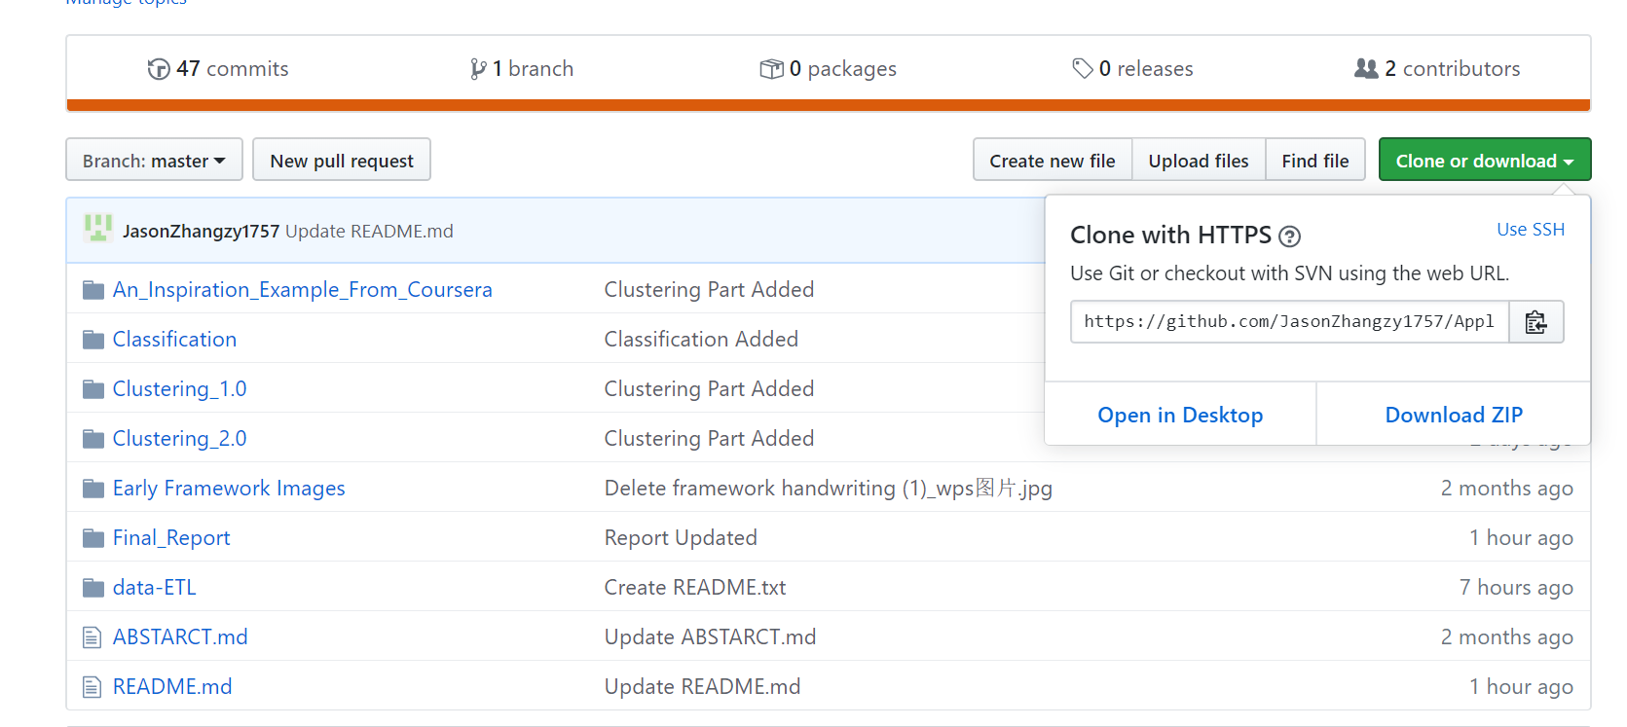

2. Make changes in the file or addfiles whatever on your local computer.

3. **git status**

Check the status of the git: The red ones are those you changed

(pwd ---- the current path

cd XXXX ---- to a new path

cd .. ---- get back to original path

tab ---- complete names appeared or you entered before)

4. Create a new Branch

**git checkout -b XXXX** (zz2498/validation) ---- Switch to a new branch

5. **git add XXXX** ---- add new changes to the processing space

(git status Check if the files been prepared)

6.Commit

**git commit -m "description"** ---- commit the files from processing space to local git

7.Push

**git push origin zz2498/validation** (branch name, could use tab here) ---- push the files in local git to remote git.

8.Pull Request (Close Git Bash, Open Github)

click branch and find my branch

create new pull request

add description

And that will be all